**First PDF: Convert PDF To Word (DOC), Text & Several Image Formats**

Looking for a PDF manipulation tool that can quickly convert PDF documents into Word and Text format without having to manually configure conversion settings? Try **First PDF.** It’s a simple, free Windows application that allows you to not only convert PDF documents to DOC and Text format, but also to export them in different image formats, namely PNG, JPEG, TIFF, BMP, GIF and Multi TIFF. The application may prove to be extremely useful in instances where you want to convert a PDF file to an editable MS Word DOC file or if you want to embed a specific page of a PDF document into your website, as an image. As far as PDF to DOC conversion is concerned, it has the ability to preserve the text formatting as well as other applied text styles without changing the original structure of the document. More details after the jump.

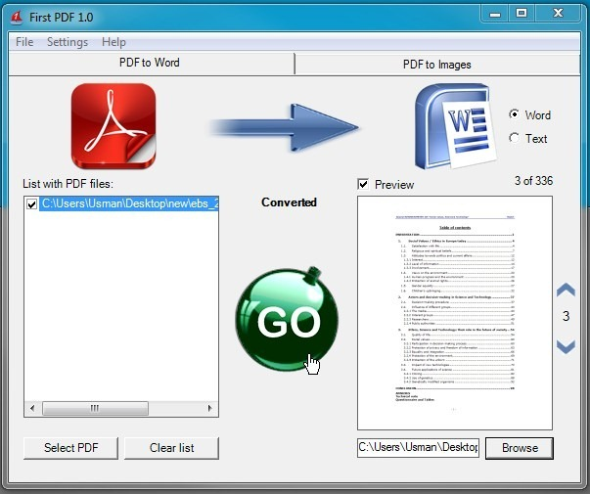

Nesting HTML Tables

"What on earth is nesting?" may be the first thing that you ask. Well, the way I would describe it is placing something within something else. "something else" acts as the container of "something". with me? When you nest tables, the 'nested' table is contained within another table, which *contains* it. This is quite useful for creating table based layouts.

Lets say you have a page and you would like a navigational part on the left with content on the right. You dont want to use frames, and layers are too fiddly. A good way to create this kind of effect is by using nested tables. A table which contains 2 other tables, one of the 2 inner tables would be quite narrow and on the left (for the navigation) and then the other table on the right with the majority of the page space available to it. (content)

<table width="500" cellspacing="2" border="1">  
<tr>  
<td><div align="left"><b>The containing table</b></div>  
<table width="120" cellspacing="2" cellpadding="2" align="left" border="1">  
<tr>  
<td>A nested table</td>  
</tr>  
</table>  
<table width="380" cellspacing="2" cellpadding="2" align="right" border="1">  
<tr>  
<td>Another nested table</td>  
</tr>  
</table>  
</td>  
</tr>  
</table>

# This will produce something a little like this...: HTML Table Border

This page contains HTML table border code - HTML codes for specifying or changing the border of your tables within your blog or web page.

HTML table border is specified using [Cascading Style Sheets](http://www.quackit.com/css/) (CSS).

## Typical Table Border

To set the border of an HTML table, use the CSS [border](http://www.quackit.com/css/properties/css_border.cfm) property.

## Collapse the Border

You can remove the space in between the cells by applying the CSS [border-collapse](http://www.quackit.com/css/properties/css_border-collapse.cfm) property to the [table](http://www.quackit.com/html/tags/html_table_tag.cfm) element.

Example:

|  |  |
| --- | --- |
| **Table header** | **Table header** |
| Table cell 1 | Table cell 2 |

Example:

|  |  |
| --- | --- |
| **Table header** | **Table header** |
| Table cell 1 | Table cell 2 |

## Bottom Border

|  |  |
| --- | --- |
| **Table header** | **Table header** |
| Table cell 1 | Table cell 2 |

<BODY TEXT="#**_choose_color_**" LINK="#**_choose_color_**" VLINK="#**_choose_color_**" ALINK="#**_choose_color_**" BGCOLOR="#**_choose_color_**" BACKGROUND="**_choose_image_**">

<TABLE ALIGN=center BORDER=2 CELLSPACING=0 CELLPADDING=5 WIDTH="90%" BGCOLOR="#**_choose_color_**" BACKGROUND="**_choose_image_**" BORDERCOLOR="**_choose_color_**" <TR><TD>

<BR><BR>  
  
<TABLE ALIGN=center BORDER=2 CELLSPACING=0 CELLPADDING=5 WIDTH="80%" BGCOLOR="#**_choose_color_**" BACKGROUND="**_choose_image_**" BORDERCOLOR="**_choose_color_**" <TR><TD>

<BR><BR>

*Start your text here ...*  
Put whatever you want to have ... images, text, etc.  
At the end of your page, finish it off with:

</TD></TR></TABLE>  
<BR><BR>  
  
</TD></TR></TABLE>  
<BR><BR>  
  
</BODY></HTML>

# HTML Paragraphs

HTML documents are divided into paragraphs.

**bullet lists**  
The following example shows a bullet list with three items.

<ul>  
<li>First item  
<li>Second item  
<li>Third item  
</ul>

This is what it looks like:

* First item
* Second item
* Third item

Bullet lists are indented from the main text, and a line is skipped:

This is the main text, notice there is no code for a line break  
<ul>  
<li>First item  
<li>Second item  
<li>Third item  
</ul>

This is the result:  
This is the main text, notice there is no code for a line break

* First item
* Second item
* Third item

The browser will remove extra spaces and extra lines when the page is displayed. Any number of lines count as one line, and any number of spaces count as one space. (The example demonstrates some HTML formatting problems)